This document is merely to point out the differences in confessional count numbers between my findings and the official numbers posted on Survivor Sucks. The guidelines I use can be found [here](https://docs.google.com/document/d/18ofsPiVWxSejzSjEGlU8KEx4Og2ddEJScCV23RsCPIA/edit?usp=sharing).

**Survivor Sucks Season 06 Counts** ([link](https://goo.gl/photos/ywsqQPj32cJrVcec8))

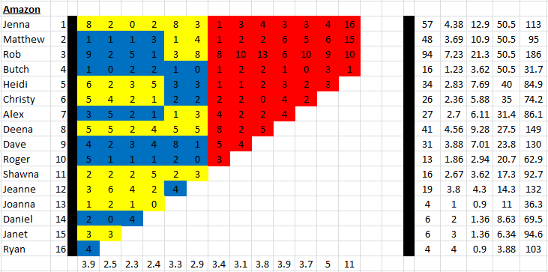

**My Season 06 Counts** (link)

**Differences**

[Episode 01](https://docs.google.com/document/d/1CxmNHAx2lY_HNpcnZt5telEgcyT0qbAxfeMsax1Oe8E/edit?usp=sharing)

* **Jenna 9 (+1)** I got a total of 9 confessionals for Jenna instead of the established 8. No significant gaps.
* **Rob 12 (+3)** Confessional #48 has a 12s gap and confessional #72 has a 15s gap.
* **Heidi 7 (+1)** I got a total of 7 confessionals for Heidi instead of the established 6. No significant gaps.
* **Alex 4 (+1)** Confessional #19 has an 11s gap.
* **Deena 6 (+1)** Confessional #26 has a 10s gap.
* **Shawna 3 (+1)** Confessional #6 is a voice over.
* **Jeanne 5 (+2)** Confessional #54 has a 10s gap.
* **Janet 4 (+1)** I got a total of 4 confessionals for Janet instead of the established 3. No significant gaps.
* **Note:** After confessional #23 there are two instances (with less than 10s apart) where Jeanne comments about the women beating the men and that they are Amazonian women. It may be considered and on-the-fly confessional as she looks to the camera for an instant. BTW, this season is filled with moments like this. Just in this episode, there are two more scenes like this.

Episode 0

**No Change**

* Episode

|  |  |  |
| --- | --- | --- |
| **Castaway** | **Count** | **Change** |
|  |  |  |
| **Total** |  |  |

**Revised Sucks Counts** (link)